UNWTO Regional conference
Enhancing Brand Africa
Fostering Tourism Development
Accra, Ghana, 17-19 August 2015

The UNWTO Regional conference was held from to 17-19 August in Accra the capital of Ghana. Tourism Stakeholders, Ministers, Associations, the Private Sector, Media and Communication Organizations and other sectors with interest in tourism were in attendance.
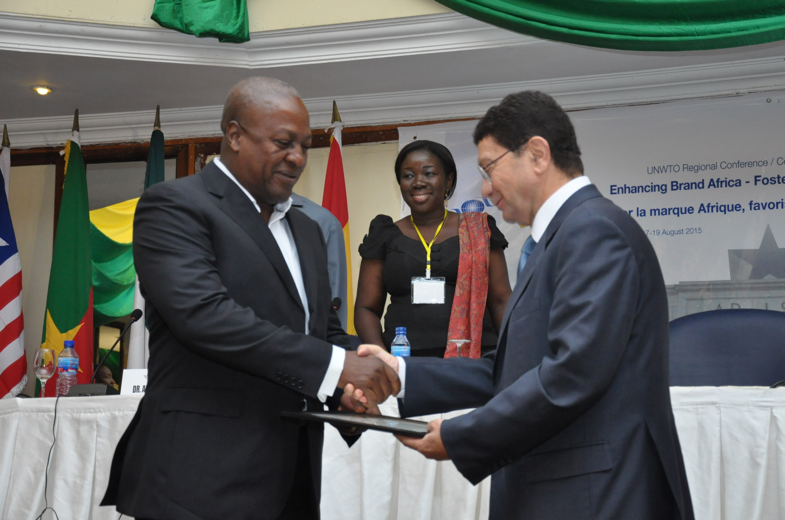
The high profile delegates who attended the conference were the President of Ghana, his Excellency John Dramani MAHAMA who opened the conference, Dr Alfred Oko Vanderpuje, the Accra Mayor, The Secretary –General of UNWTO, Dr Taleb Rifai, Hon. Mrs. Elizabeth Ofosu-Adjare, Minister of Tourism, Culture and creative arts of Ghana, Dr Elham M.A Ibrahim. Commissioner of Infrastructure and Energy of Africa Union. ----The conference focused on the situation of Brand Africa and its impact on tourism in the region ,the identification of key challenges facing Brand Africa, exchanging of National experiences on country and tourism branding ,exploring how Africa destination s can successfully build a strong brand in an increasing competitive marketplace in a constantly changing business environment , creation of synergies among African countries towards greater cooperation in the promotion and positioning of a common African Tourism Brand
From Left to Right (Major of Accra, Min. of Tourism and Creative Arts of Ghana, President of Ghana and Sec. Gen. of UNWTO)
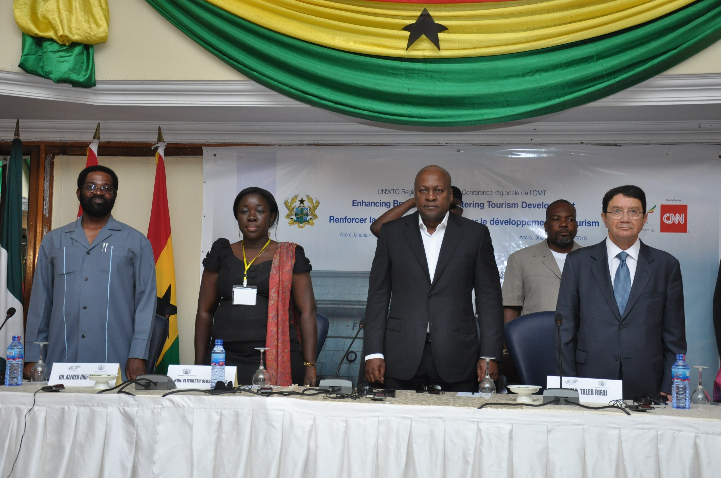
The President of Ghana (Left) with the Secretary General of UNWTO
The main areas of discussion were: Position and Brand, E-Communications, Media relations, Crisis communications, Public/Private Partnerships and Resources and capacity building. Some of the key speakers were from CNN, UNWTO, Ethiopia Airlines, and Yellow Railroad. Africa Union, UNDP, UNICEF, Bench Events, Tastemakers Africa, Brand Africa…..and some tourism ministers from African countries. Recommendations were made and each country is expected to factor them in their tourism development agenda.
Some of the Participants
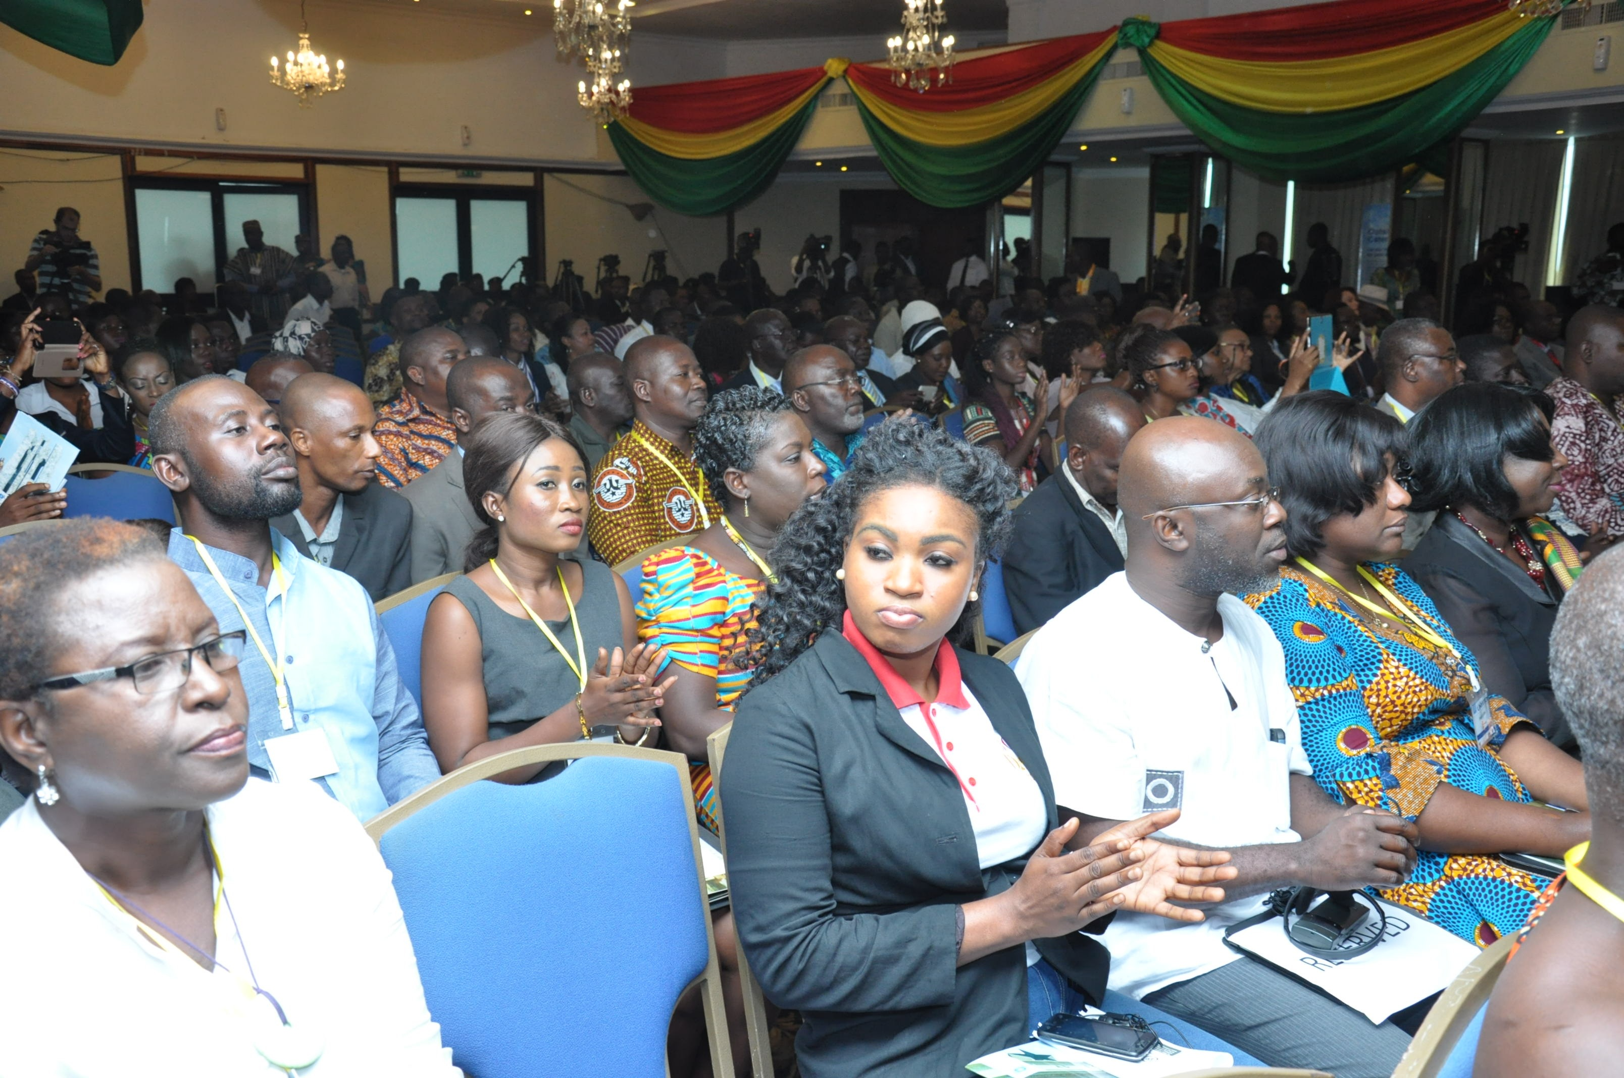
Paul –Romeo Essessi (Individual Member of WFTGA)
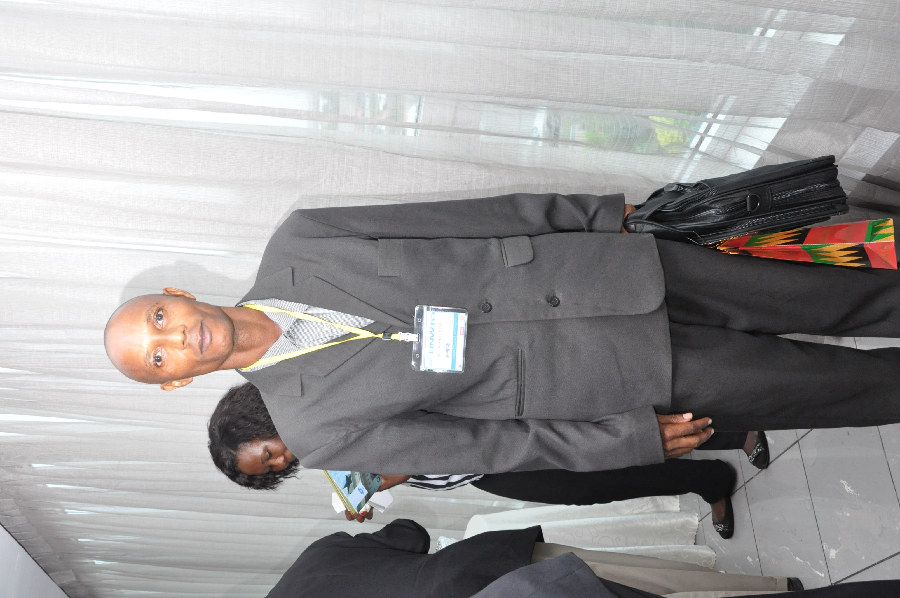

The third day was mainly site visits to some attractions in Accra-the capital of Ghana
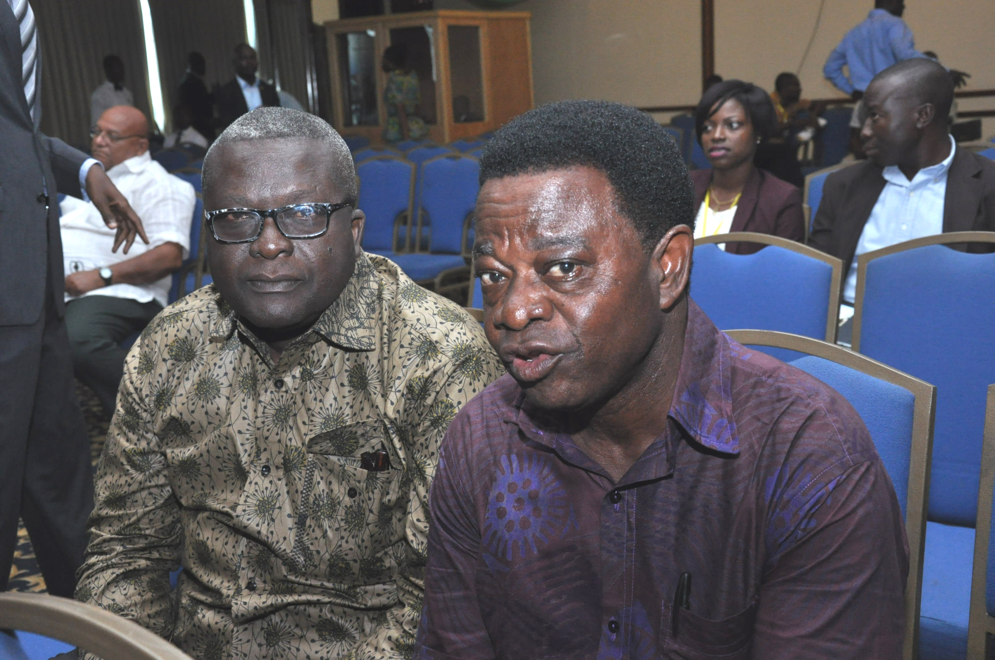

Sam Baidoo (Left) Area Representative of WFTGA

Paul-Romeo Essessi
Tourist Guide
Tel : 00233244923292
00233278585587
Email : parokess@yahoo.com
Accra, Ghana

